**Week 17**

*Written by Kaarlo*

This week we had made a reservation to FabLab for printing parts on Friday so when we met on Tuesday, we focused on finishing the programming part of our project. Konsta had made some modifications to the display of our radar so we got this updated look.

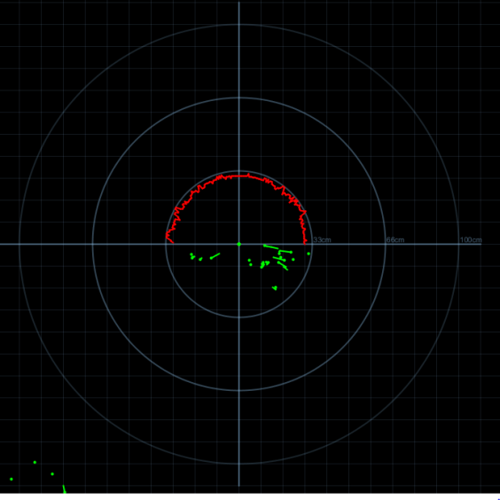

We managed to get the code working well on our project and everything looked now how we liked it. As we had not much experience on working with Android + Bluetooth and everything worked nicely on the computer, we decided to demo our project on the computer instead of the phone. So now we had a working circuit gathering data from its environment, sending it to the computer via Bluetooth and visualizing it there clearly and nicely.

Like earlier we had the TA-session on Wednesday and we didn’t have so many questions there. When asked for 3D-printing time from the supervisor, he said it depends on but roughly it would take approximately 1 hour per 1 cm of height. We prepared to leave the printer working over the weekend.

On Friday Aleksanteri and Aleksi went to the FabLab to print the parts. Everything went well and they managed to get every part printed during the time on the FabLab on Friday.

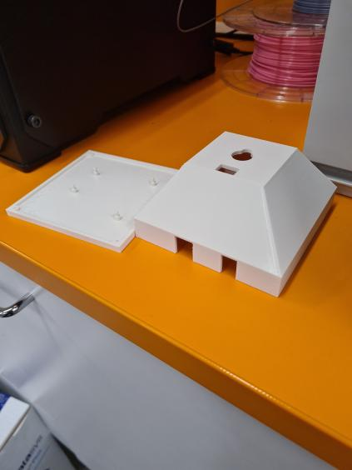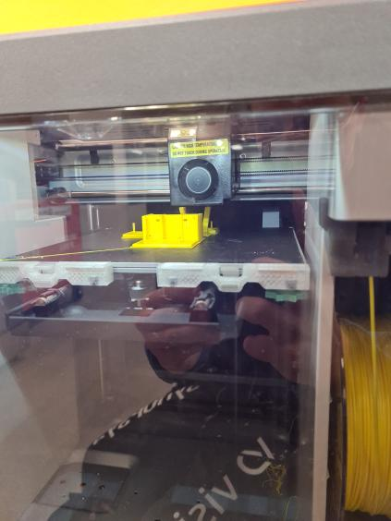

Next week (week 18) we have our final presentation on Tuesday so everything we still have to do is to put all parts together and document a demonstration of the result of our project. Aleksi has changed our repository from Drive to GitHub as it was a preferred option and we have to finish these reports and prepare for the presentation.

Project team: Aleksanteri, Aleksi, Konsta and Kaarlo